LisheBora e-Sourcing Platform

System Development Brief
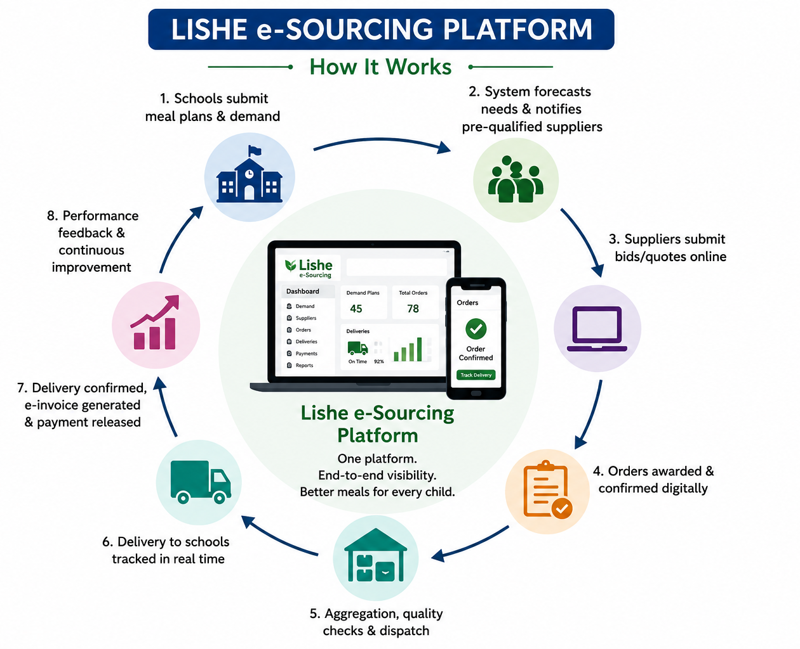

Table of Contents
Contents 2
Background and Purpose 3
Overall System Objective 3
Proposed User Groups 4
Proposed System Architecture 4
Core Functional Modules 5
5.1 System Administration and Master Data 5
5.2 School Demand and Procurement Planning 5
5.3 Menu and Nutrition Planning 6
5.4 Supplier Registration and Prequalification 7
5.5 Electronic Sourcing and Order Management 7
5.6 Bid Evaluation, Approval and Award 8
5.7 Aggregation and Quality Assurance 9
5.8 Delivery and Logistics Management 9
5.9 Electronic Invoicing and Payment Tracking 10
5.10 Dashboards, Reporting and Analytics 10
5.11 Feedback, Grievance and Continuous Improvement 11
End-to-End System Workflow 12
Key Business Rules 12
Inclusion and Accessibility Requirements 13
Security, Privacy and Audit Requirements 14
Priority MEAL Indicators 14
Proposed Development Phases 15
Minimum Acceptance Criteria 17
Issues to Confirm During Inception 17

Background and Purpose
The STEP School Feeding Project seeks to design and pilot an inclusive, transparent and efficient procurement system that strengthens linkages between schools, local producers, aggregators and other suppliers. Diagnostic studies identified several weaknesses in existing sourcing arrangements, including fragmented demand planning, limited supplier visibility, informal procurement processes, weak aggregation, delayed payments, inadequate traceability and limited access for women, youth, persons with disabilities and smallholder producer groups.
The LisheBora e-Sourcing Platform is proposed as a digital coordination and procurement system that will manage the sourcing cycle from school meal planning and demand forecasting through supplier selection, aggregation, delivery, payment and performance monitoring. The platform should complement existing government procurement, school management and financial systems rather than create a parallel regulatory process.

Overall System Objective
To provide a secure, accessible and transparent digital platform that connects school food demand with qualified local suppliers and supports efficient planning, procurement, aggregation, quality assurance, delivery, payment and monitoring of school meal ingredients.
The platform should:
- Improve the predictability and visibility of school food demand.
- Expand fair access to procurement opportunities for local suppliers.
- Reduce procurement cycle times and administrative costs.
- Strengthen food quality, safety and traceability.
- Improve the timeliness and transparency of supplier payments.
- Generate real-time information for schools, counties, suppliers and programme managers.
- Support inclusive procurement by tracking participation and benefits for women, youth, persons with disabilities and marginalized producer groups.
- Strengthen accountability through digital approvals, audit trails and performance reporting.

Proposed User Groups
User group | Primary system role
Schools, headteachers and school meals committees | Enter enrolment, meal plans, stock levels and food requirements; initiate sourcing requests; confirm deliveries; provide supplier feedback.
County and municipal authorities | Approve procurement plans, oversee budgets, monitor schools, manage supplier eligibility and review county-level performance.
Farmer groups, cooperatives and aggregation hubs | Register members and commodities; consolidate produce; undertake sorting, grading and dispatch; maintain traceability records.
Suppliers, traders and MSMEs | Register and submit eligibility documents; receive sourcing notices; submit bids or quotations; fulfil orders; issue invoices.
Quality inspectors and food-safety officers | Record inspections, test results, accepted and rejected quantities, compliance status and corrective actions.
Finance, treasury and payment units | Verify invoices, approve payments, record disbursements and monitor outstanding obligations.
Project management and MEAL teams | Monitor implementation, inclusion, efficiency, outcomes, risks and learning across counties and schools.
System administrators | Configure workflows, permissions, commodity specifications, approval thresholds, reporting periods and user accounts.

Proposed System Architecture
The system should adopt a modular, mobile-first and API-enabled architecture comprising:
User interface layer: A responsive web portal and mobile-friendly interface for schools, suppliers, aggregators, county officers and administrators. Offline data capture and synchronization should be considered for locations with unreliable connectivity.
Application layer: Modules for demand planning, supplier management, sourcing, evaluation, quality assurance, logistics, payments, reporting and feedback.
Data layer: A secure relational database for transactions and master data, a document repository for supplier and procurement records, and an immutable audit log recording all system actions.
Integration layer: Interfaces for SMS and email notifications, mobile money and banking systems, county financial systems, school information systems and relevant government procurement platforms. Initial implementation may use structured file exchange where direct APIs are unavailable.
Analytics layer: Dashboards, automated reports, alerts and downloadable datasets for operational management, MEAL and donor reporting.

Core Functional Modules

5.1 System Administration and Master Data
The administration module will establish the common reference information used throughout the platform. It should manage counties, sub-counties, schools, school clusters, academic terms, feeding days, commodities, units of measurement, standard portions, nutrition specifications, quality standards, procurement thresholds, approval hierarchies and user permissions.
Administrators should be able to configure these parameters without requiring changes to the system source code.

5.2 School Demand and Procurement Planning
Schools will enter or update:
- Learner enrolment and expected daily attendance.
- Number of planned feeding days.
- Approved menus and meal frequency.
- Existing food stocks and anticipated opening balances.
- Commodity requirements by quantity, quality and delivery date.
- Available budgets and funding sources.
- Preferred delivery schedules and storage capacity.
The system will calculate commodity requirements using enrolment, feeding days, menu composition and standard portion sizes. School-level needs will then be consolidated by cluster, sub-county or county to identify opportunities for bulk sourcing and coordinated delivery.
The platform should generate annual and termly procurement plans that can be reviewed and approved by designated authorities.

5.3 Menu and Nutrition Planning
The platform should support nutrition-sensitive menu planning by allowing authorized users to:
- Develop and approve weekly or termly menus.
- Link each meal to standard food quantities and nutrient groups.
- Identify locally available and seasonal food alternatives.
- Flag menus that lack minimum diversity or approved food groups.
- Estimate commodity demand generated by each menu.
- Track the frequency of vegetables, fruits, legumes, animal-source foods and other nutritious ingredients.
Nutrition parameters should remain configurable and be validated by the relevant technical authorities before pilot deployment.

5.4 Supplier Registration and Prequalification
Suppliers should be able to create profiles through a simplified registration process. Profiles should capture:
- Supplier type: farmer, group, cooperative, aggregator, trader, processor or MSME.
- Location and operating areas.
- Commodities offered and seasonal availability.
- Estimated production or supply capacity.
- Registration and tax documents.
- Food-safety and quality certifications.
- Bank or mobile payment information.
- Storage, transport and aggregation capacity.
- Gender, age, disability and enterprise ownership information.
- Membership of farmer groups or cooperatives.
- Previous supply experience and references.
The system should provide assisted registration options for suppliers with limited digital literacy. Supplier documents should have expiry dates and automated renewal alerts.
Prequalification workflows should allow technical and procurement teams to verify documents, inspect facilities where required, approve eligible commodity categories and record any conditions attached to approval.

5.5 Electronic Sourcing and Order Management
Based on approved demand, the platform should support different sourcing approaches, including requests for quotations, competitive bids, framework agreements, direct sourcing under approved thresholds and call-off orders.
The module should allow authorized officers to:
- Create sourcing notices and commodity lots.
- Specify quantity, quality, location and delivery requirements.
- Define eligibility, evaluation and inclusion criteria.
- Set bid submission and clarification deadlines.
- Notify eligible suppliers through the platform, SMS or email.
- Receive and securely store quotations and supporting documents.
- Issue clarifications and amendments to all affected suppliers.
- Close submissions automatically at the specified deadline.
The sourcing process should be transparent while preserving the confidentiality of bids before the closing date.

5.6 Bid Evaluation, Approval and Award
The system should support configurable technical and financial evaluation criteria. These may include:
- Price and total evaluated cost.
- Supplier capacity and previous performance.
- Ability to meet required volumes and schedules.
- Quality and food-safety compliance.
- Local sourcing and distance to delivery point.
- Participation of women-, youth- and PWD-led enterprises.
- Agroecological or sustainable production considerations.
- Availability of storage, aggregation and transport arrangements.
Evaluation committee members should complete individual scores and conflict-of-interest declarations. The platform should calculate consolidated scores while retaining a complete audit trail.
Awards should pass through the required approval hierarchy before purchase orders or framework contracts are generated. Unsuccessful suppliers should receive standardized notifications and have access to an approved clarification or grievance process.

5.7 Aggregation and Quality Assurance
Aggregation hubs should use the system to record produce received from individual farmers or supplier groups. Records should include:
- Farmer or supplier identity.
- Commodity and variety.
- Quantity delivered.
- Date and source location.
- Batch or lot number.
- Quality grade.
- Inspection results.
- Accepted, rejected or downgraded quantity.
- Reason for rejection or corrective action.
- Final quantity allocated to a school order.
The system should support traceability from the school delivery back to the aggregation hub and, where practical, to the contributing producer group or farmer.
Quality inspectors should be able to capture results using mobile devices, upload photographs and issue digital clearance before dispatch. The detailed standards and inspection procedures will be developed with food-safety and quality authorities.

5.8 Delivery and Logistics Management
The logistics module should support:
- Consolidation of approved school orders.
- Dispatch planning by route and delivery date.
- Assignment of vehicles, drivers or logistics providers.
- Generation of dispatch notes and delivery schedules.
- Real-time or milestone-based delivery updates.
- Recording of delays, shortages, damage or substitutions.
- Electronic proof of delivery.
- School-level confirmation of quantities and quality received.
- Return, rejection and replacement workflows.
GPS tracking may be introduced where practical, but the minimum pilot requirement should be digital dispatch, delivery confirmation and exception reporting.

5.9 Electronic Invoicing and Payment Tracking
Once a delivery is accepted, the platform should generate or receive an electronic invoice linked to the purchase order, dispatch record and goods-received confirmation.
The payment workflow should support:
- Three-way matching of order, delivery and invoice.
- Verification and approval of invoices.
- Recording of deductions, rejected quantities or adjustments.
- Submission to the relevant finance or treasury unit.
- Tracking of payment status and processing time.
- Automated reminders for overdue approvals or payments.
- Notification to the supplier when payment is approved and completed.
- Reconciliation of partial and final payments.
Direct integration with mobile money, banking or government financial systems should be assessed during system design. Where direct integration is not initially possible, payment reference numbers and status updates should be captured within the platform.

5.10 Dashboards, Reporting and Analytics
The platform should provide role-specific dashboards showing information such as:
- Total demand by school, county, commodity and term.
- Number and value of sourcing opportunities.
- Supplier registration and prequalification status.
- Local sourcing share.
- Participation and contract value secured by women, youth and PWD suppliers.
- Procurement cycle time.
- Order fulfilment and on-time delivery rates.
- Quantities accepted, rejected or lost.
- Supplier performance scores.
- Outstanding invoices and average payment time.
- Menu diversity and nutrition-sensitive sourcing indicators.
- Aggregation volumes and number of contributing farmers.
- Procurement expenditure and budget utilization.
- Complaints, grievances and resolution status.
Reports should be exportable to Excel and PDF and should allow filtering by date, county, school, supplier category, commodity and inclusion group.

5.11 Feedback, Grievance and Continuous Improvement
Schools, suppliers and aggregators should be able to submit feedback and complaints through the platform. The system should record:
- Nature and category of complaint.
- Transaction or order concerned.
- Date submitted.
- Responsible officer.
- Action taken.
- Resolution date.
- Complainant satisfaction.
Supplier performance should be assessed after each completed order using indicators such as quality, timeliness, completeness, responsiveness and compliance. Schools and procurement units should also be evaluated on payment timeliness and adherence to agreed processes.

End-to-End System Workflow
- Demand entry: Schools enter enrolment, menus, feeding days, available stocks and projected requirements.
- Demand consolidation: The system calculates and consolidates demand by commodity, school cluster, delivery period and geographic area.
- Sourcing initiation: Approved requirements are converted into sourcing notices, RFQs, tenders or framework call-offs.
- Supplier notification and bidding: Prequalified suppliers receive alerts and submit quotations or bids through the platform.
- Evaluation and award: Authorized committees evaluate submissions, complete approvals and issue digital awards or purchase orders.
- Aggregation and quality control: Farmer groups, suppliers or aggregators consolidate produce, conduct quality checks and prepare orders for dispatch.
- Delivery and confirmation: Deliveries are tracked, and schools record quantities and quality received through electronic proof of delivery.
- Invoice and payment: The platform generates or validates the invoice, routes it for approval and tracks the payment until settlement.
- Performance and learning: Supplier and buyer performance is recorded, complaints are resolved and transaction data feeds dashboards and programme learning.

Key Business Rules
The following rules should be configurable and validated during system co-design:
- Only active and prequalified suppliers may respond to restricted sourcing opportunities.
- No procurement process may proceed without an approved demand plan and confirmed budget.
- Initiation, evaluation, approval, receipt and payment functions should be separated among different authorized users.
- All transactions must be time-stamped and recorded in the audit trail.
- Changes to quantities, specifications, deadlines or evaluation criteria must be formally approved and communicated.
- Purchase orders should not exceed approved budgets or supplier capacity without authorization.
- Deliveries cannot be invoiced until receipt and quality acceptance are recorded.
- Rejected or partially accepted deliveries must generate a documented exception.
- Payment timelines should begin from the date of complete acceptance and submission of a valid invoice.
- Supplier inclusion status should be verified rather than self-declared only.
- Conflict-of-interest declarations should be mandatory for evaluation and approval officers.
- System users should only access information required for their assigned responsibilities.

Inclusion and Accessibility Requirements
The platform should be designed for users with different levels of digital literacy and connectivity. It should therefore provide:
- Simple, clear and mobile-friendly screens.
- Assisted supplier registration.
- SMS and email notifications.
- Offline or low-bandwidth functionality for selected operations.
- English and Kiswahili language options where feasible.
- Accessibility features for users with disabilities.
- Group-based supplier registration for cooperatives and self-help groups.
- Disaggregated reporting by gender, age, disability, geography and enterprise type.
- Transparent visibility of available procurement opportunities and award decisions.

Security, Privacy and Audit Requirements
The system should include:
- Secure user authentication and password management.
- Role-based access controls.
- Encryption of sensitive data in transit and at rest.
- Secure backup and disaster-recovery arrangements.
- Automated session controls and account-locking mechanisms.
- Full audit logs for registration, evaluation, approvals, deliveries and payments.
- Controlled access to personal, financial and supplier information.
- Consent and privacy notices for registered users.
- Procedures for correcting, retaining and deleting data.
- Periodic security testing and vulnerability assessment.
The final design must comply with applicable Kenyan data-protection, public procurement and financial management requirements.

Priority MEAL Indicators
The platform should generate data for the following performance areas:
- Number and value of procurement opportunities processed.
- Percentage of food sourced locally.
- Share of contract value secured by women, youth and PWD suppliers.
- Number of farmers linked through aggregators or producer groups.
- Average procurement cycle time.
- Average payment turnaround time.
- Percentage of orders delivered on time and in full.
- Commodity rejection and loss rates.
- Number of schools using demand forecasts and approved menus.
- Dietary diversity of procured food baskets.
- Supplier retention and repeat participation.
- Private sector and aggregator investment leveraged.
- Number and resolution rate of grievances.
- Cost savings or efficiency gains achieved through consolidated procurement.

Proposed Development Phases
Phase 1: Requirements validation and co-design
Conduct user consultations with schools, county officials, suppliers, aggregators, quality officers and finance teams. Confirm procurement workflows, approval levels, data requirements, legal constraints and integration opportunities.
Phase 2: Prototype development
Develop interactive screen prototypes and process simulations. Validate usability with representative users before full coding.
Phase 3: Minimum Viable Product development
The initial version should prioritize user management, school demand planning, supplier registration, RFQs, bid submission, evaluation, award, delivery confirmation, invoice tracking, notifications and basic dashboards.
Phase 4: Pilot deployment
Deploy the platform in selected schools and counties. Train users, provide help-desk support, monitor transactions and document usability, operational and regulatory issues.

Phase 5: Refinement and advanced functionality
Incorporate pilot feedback and add advanced forecasting, integration with financial systems, enhanced offline functionality, GPS tracking, nutrition analytics, supplier performance tools and broader reporting.
Phase 6: Scale-readiness assessment
Assess technical performance, user adoption, operating costs, governance requirements, hosting arrangements and institutional ownership before expansion.
12. Expected Developer Deliverables
The ICT specialist or firm should provide:
- Detailed business and system requirements specification.
- User journey maps and validated process flows.
- Technical architecture and database design.
- Interactive user-interface prototype.
- Minimum Viable Product.
- Web and mobile-responsive interfaces.
- Administrator, school, supplier, aggregator and oversight dashboards.
- API and integration documentation.
- Data security and privacy framework.
- Testing plans and test reports.
- User manuals and training materials.
- System deployment and hosting documentation.
- Maintenance, support and backup plan.
- Source code and system configuration documentation.
- Pilot performance report and recommended improvements.

Minimum Acceptance Criteria
The pilot system should be considered functional when:
- Authorized users can complete the full sourcing cycle from demand entry to payment tracking.
- The system supports multiple schools, counties, commodities and supplier types.
- Supplier eligibility and supporting documents can be verified digitally.
- Procurement approvals follow configurable workflows.
- Every transaction has a complete and retrievable audit trail.
- Deliveries can be traced from the school to the supplier or aggregation point.
- Payment status and delays are visible to authorized users.
- Dashboards provide accurate and disaggregated operational information.
- The platform works on standard web and mobile devices.
- Data can be exported for analysis and donor reporting.
- User testing confirms that the platform is understandable and usable by school and supplier representatives.
- Security, backup and recovery tests have been successfully completed.

Issues to Confirm During Inception
The development team should facilitate agreement on the following before finalizing the system design:
- Counties and schools included in the first pilot.
- Procurement methods and financial thresholds to be supported.
- Institutional owner and long-term system administrator.
- Hosting location and data ownership arrangements.
- Approved nutrition standards and commodity specifications.
- Supplier prequalification and inclusion criteria.
- Payment systems and government platforms available for integration.
- Level of offline functionality required.
- Languages required for the pilot.
- Roles responsible for quality inspection and certification.
- Support, maintenance and operating-cost arrangements after the pilot.
The LisheBora e-Sourcing Platform should ultimately function as more than an electronic tendering tool. It should provide an integrated system for translating school meal plans into predictable demand, connecting that demand to inclusive local supply, protecting food quality, accelerating payments and generating evidence for continuous improvement of Kenya’s Home-Grown School Feeding systems.

